26.9.16 Editors - Properties Editor - Particle Properties Tab - Hair - Field Weights panel
Field weights panel 1
Effector Collection 1
Gravity 1
All 1
Force, Vortex, etc. 1
Use For Growing Hair 1
Effect Children 1
Stiffness 1

Field weights panel
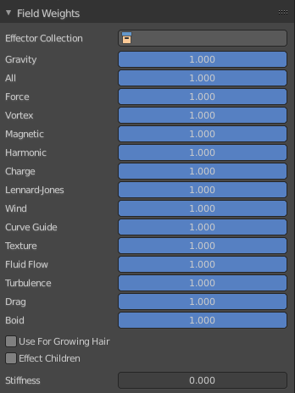
The Field Weight panel allows you to control how much influence each type of external force field, or effector, has on the particle system. Force fields are external forces that give dynamic system’s motion.

Effector Collection
Limit effectors to a specified group. Only effectors in this group will have an effect on the current system.

Gravity
Control how much the Global Gravity has an effect on the system.

All
Scale all of the effector weights.

Force, Vortex, etc.
The influence for the single corresponding effector weights.

Use For Growing Hair
Use force fields when growing hair.

Effect Children
Apply effectors to children

Stiffness
Hair stiffness for effectors.

